24GE 4 10G SFP L2 L3 Managed Rack-mount Network Switch

Model: QF324G-10GX-L3

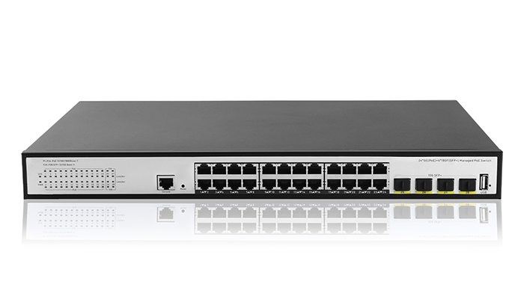

**Full Gigabit Ports**: 24× gigabit ports , 4 × gigabit RJ45 ports, 4× gigabit SFP provide high-speed connections.

**Installation**: Rack-mounted installing style **Switching Capacity** 66Gbps

**Support STP, RSTP, MSTP fast Spanning Tree Protocol;**

**Supports the ERPS ring network protocol Supports multiple management methods such as CLI command line, web management, SNMP, and SSH**

**Features**

The switch is is a full Gigabit managed Network switch independently developed by QIFANG. it has 24*10/100/1000M ports, 4*10G SFP fiber slot ports . It supports half-duplex flow control and full-duplex back pressure ,each port supports auto-adaptive function, provides an economical, practical, high cost-effective sharing device for broadband LAN .

1. Supports IEEE 802.3i，IEEE 802.3u，IEEE802.3ab，IEEE802.3z，IEEE802.3x，IEEE802.3az. 2. 24× 10/100/1000BASE-T and 4× 10 Gigabit SFP. 3. Non-blocking exchange frame, full wire-speed transmission and max.throughput filter the data packet.

4. Supports MAC address auto-learning and auto-aging.

5. Store and forward mode operates.

6. LED indicators for monitoring power, link/activity

7. Support QoS, port mirroring, link aggregation protocol.

8. 1U Rack-Mounted installation

**Specification**

|  |  |  |
| --- | --- | --- |
| **Item** | | **Description** |
| **Hardware** | | |
| Fixed port | | 24 10/100/1000Base-T ports  4 10Gigabit SFP+ ports  1 Console port  1 USB port  1 Reset port |
| LED Indicators | | PWR, Link/Act LED |
| Input voltage | | 100V～240V AC，50/60Hz |
| Power consumption | | ≤15W |
| CPU | | 1GHz |
| DDR | | 4Gb DDR3 |
| Flash Memory | | 256Mbits |
| Operating temperature | | 0℃～50℃ |
| Storage temperature | | -40℃～70℃ |
| Relative humidity | | 5%～95% (non-condensing) |
|  | | 440*290*44.5 |
| Thermal methods | | Built-in FAN |
| **L2 Switching** | | |
| Switching capacity | | 128Gbps |
| Packet Buffer | | 12Mbits |
| Throughput | | 95.232Mpps |
| **Port configuration** | | |
| Port auto-negotiation | | Support |
| Port flow control | | Support full duplex IEEE802.3x flow control  Support Half-duplex back pressure flow control |
| Broadcast storm control | | Support broadcast, multicast, DLF packet rate limit |
| Port Mirroring | | Support |
| Port Isolation | | Support |
| Port Self-loop Detection | | Support |
| Link Aggregation | | Support  Supports up to 128 aggregation groups, each group supports up to 8 ports |
| Jumbo Frame | | Jumbo packets up to 12K bytes |
| Redundant port | | Support |
| **MAC configuration** | | |
| MAC address table | | 32K |
| MAC address table management | | Support |
| Static MAC address | | Support. |
| MAC Address Binding | | Support |
| MAC Address Filtering | | Support |
| MAC Address Learning control | | Control number of port-based MAC address learning |
| **VLAN configuration** | | |
| Number of VLANs | | 4K |
| Port-based VLAN | | Support |
| 802.1q VLANs | | Support |
| MAC-based VLAN | | Support |
| IP-based VLAN | | Support |
| Protocol-based VLAN | | Support |
| Voice VLAN | | Support |
| VLAN mapping | | Support |
| QinQ | | Support |
| **Reliability Protocol** | | |
| Spanning Tree Protocol | | Support STP/RSTP/MSTP |
| ERPS Protocol | | Support G.8032/Y.1344 |
| LLDP | | Support LLDP&LLDP-MED |
| UDLP Protocol | | Fully compatible with CISCO's UDLD protocol |
| VLLP | | Support, Use with VRRP-Not support |
| **routing** | | |
| ARP | | Support static and dynamic ARP |
| Static routing | | Support |
| VLAN interface | | Support 32 VLAN interfaces |
| **L3 routing protocol** | | |
| RIP | | Support RIP v1/v2 |
| OSPF | | Support OSPF v2 |
| Policy routing | | Support |
| VRRP | | Support |
| **Multicast functions and protocols** | | |
| Static multicast MAC address | | Support |
| IGMP SNOOPING | | Support IGMP SNOOPING v1/v2/v3 |
| MVR | | Support |
| GMRP | | Support |
| **ACL access control list** | | |
| ACL based on standard IP | | Support |
| ACL based on extended IP | | Support |
| ACL based on MAC IP | | Support |
| ACL based on MAC ARP | | Support |
| ACL port filtering | | Support |
| ACL based on time | | Support |
| **QoS** | | |
| Number of port queues | | 8 |
| queue scheduling algorithms | | Support WRR,RR,WDRR,SP—Not support RR，WDRR |
| Classification based on port | | Support |
| Classification based on 802.1p | | Support |
| Classification based on DSCP | | Support |
| Classification based on ACL | | Support |
| QoS policy | | Supports mapping of different data streams to different queues  Support data stream to modify COS or DSCP value  Support the speed limit of data stream  Support data stream statistics  Support data stream mirroring |
| **DHCP** | | |
| DHCP Client | | Support |
| DHCP Snooping | | Support |
| DHCP Relay | | Support |
| DHCP Server | | Support |
| DHCP option 82 | | Support |
| **Security** | | |
| ACL | | Support Standard IP / Extend IP / MAC IP / ARP |
| Security Features | | Support MAC-based 802.1X authentication  Support AAA/RADIUS authentication  Support WEB/Telnet password protection |
| Self-protection | | Support CPU Self-protection. |
| **Management** | | |
| CLI | | Support CLI (Commend Line Interface) configuration mode |
| Console | | Support Configuration via the console port |
| Telnet | | Support Local/remote configuration via Telnet |
| WEB | | Support WEB management system |
| SNMP | | Support System configuration with SNMP v1/v2c |
| User Management | | Support Multi-user management |
| System Log | | Support |
| Configuration File Download/Upload | | Support Download/Upload configuration File via WEB/TFTP/USB |
| Upgrade Firmware | | Support Upgrade Firmware via WEB/TFTP |
| **Debug** | | |
| PING | Support | |
| TRACEROUTE | Support | |
| Telnet client | Support | |